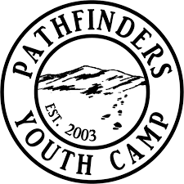

4951 Sullivan Gardens Pkwy
Kingsport, TN 37660
www.pathfindersonline.com

Event Release Form

Events: (please list events student will participate in) ______________________

Participant/Guardian Waiver

Participant (student's name) ____________________________________

In consideration of your accepting me or my child for participation in events with Pathfinders, I hereby, for myself, my heirs, executor, administrators, waive and release any and all right and claims for damages that I may have against the above-named program, activities or sports sponsored by the above-named organization.

I understand that the events may include, but are not limited to hiking, camping, rock climbing, paintball, mountain boarding, ziplining, water activities, marksmanship, ropes and team building course, obstacle courses and other high-risk activities.

I warrant that I have the right to authorize the foregoing and do hereby agree to hold Pathfinders harmless of and from any and all liability of whatever nature which may arise out of or result from such participation.

Parent/ guardian Signature _________________________________________ Date ________

Witness Signature (non-family member) ______________________________ Date ________

